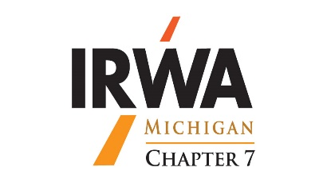
Michigan Chapter 7
2022 Schedule

Education is key…..
Chapter Meetings, Classes & Events.

May 2-3, 2022 IRWA Course 800, Principals of Real Estate Law, Virtual.
May 9-12, 2022 SR/WA Study Course, Louisville, KY – register on line with IRWA Headquarters.
May 13-14, 2022 Region 5 Spring Forum, Louisville, KY – register on line with IRWA Headquarters.
May 24-25, 2022 IRWA Course 501, Residential Relocation Assistance, Virtual
June 5-8, 2022 IRWA International Education Conference, Cleveland, OH.
June 22, 2022 Chapter 7, Lugnuts/Cooley Law Stadium, Lansing, MI.
Program – Voting & Installation of Officers & Member Appreciation.
October 7-8, 2022 Region 5 Fall Forum, Detroit, MI. Hosted by Chapter 7. Westin Hotel
September 14, 2022 IRWA Course #TBD, Soaring Eagle, Mt. Pleasant, MI, live course.
September 15-16, 2022 Chapter 7, Fall Education Conference, Soaring Eagle, Mt. Pleasant, MI.
Program-Condemnation.
November 10, 2022 Chapter 7, Weber’s Inn, Ann Arbor, MI – Program TBD.

Note, dates, times and locations are subject to change.

More information and registration forms, will be available on our Chapter 7 website: www.irwamichigan.org or IRWA HQ’s website: Courses | IRWA (irwaonline.org)
Be sure to check often as the schedule is evolving.

We are looking for a company or person to update the Chapter 7 website. If interested, please contact Gail Morton: gmorton@metroca.net or Henry Horton: hhorton@rowepsc.com

We are also looking for members to join the Executive Board and various Committees. Reach out to any Board member if you’re interested. If you have any questions, please contact us Gail Morton 269- 350-1574, or Henry Horton 810-444-5447. Many hands make light work.

Hope to see you at the next event!

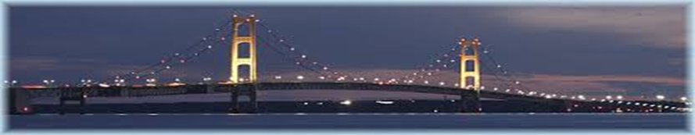
Improving people’s quality of life through infrastructure development

