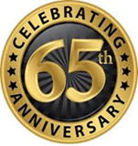
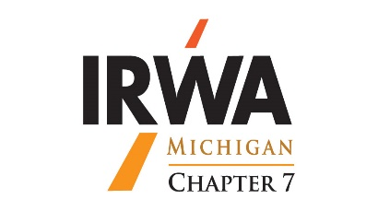
Michigan Chapter 7
Fall Education Seminar
September 23 -24, 2020
Mission Point, Mackinac Island, MI

As a reward to our essential IRWA members our Chapter 7 Sponsors are offering,
Member and Guest registration fees for the Fall Education Seminar when made on or before August 22, 2020 for $20.20*
Registration fees include, Star Line Ferry tickets from Mackinaw City to Mackinac Island, fabulous meals,
a Mackinac Island Scavenger Hunt w/ a bicycle. Plus, a wonderful variety of great speakers and presentations.

It’s time to reconnect, educate and celebrate 2020 and our essential IRWA Chapter members!
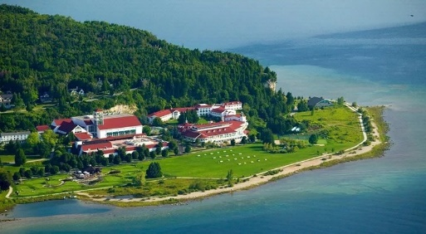
Make your Room Reservations at Mission Point today!
By phone: 800-833-7711 or email: International Right of Way Association

Room rentals are $199 per night plus island taxes and Porter services.
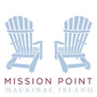

Please make checks payable to: IRWA Chapter 7
Mail registration to: Eric Wegner, 3375 E. Hubbard Road, Midland, MI 48642: 989-677-2510

Registrations can also be made by PayPal using credit card at the chapter website: www.irwamichigan.org
If using PayPal please e-mail a copy of the registration form to: Eric.Wegner@enbridge.com

Name
_________________________________________________________________________________________________________________________Company/Agency IRWA Membership No.
_________________________________________________________________________________________________________________________Address
_________________________________________________________________________________________________________________________City State Zip Code
_________________________________________________________________________________________________________________________Phone/Work E-mail Address

Appraiser name as it appears on license License No. and Type
_________________________________________________________________________________________________________________________Real Estate Broker name as it appears on license License No. and Type

Real Estate Sales name as it appears on license License No. and Type

Spouse/Guest

Spouse/Guest

*Members Early Registration – Until 8/22/2020 $20.20 $
*Members Late Registration – 8/23/2020 $100.00 $
*Guest Early Registration – Until 8/22/2020 $20.20 $
*Guest Late Registration – 8/23/2020 $100.00 $
TOTAL $

For questions, contact Gail Morton (269) 350-1574 or Henry Horton (810) 444-5447
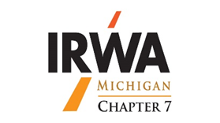
Michigan Chapter 7
Fall Education Seminar
September 23 - 25, 2020

We are closely watching the Governor’s mandates so we can provide as much notice as possible if there are any schedule changes. Everyone’s health and safety is our top priority. Mackinac Island is 1-Phase ahead of much of the State with their COVID-19 protocol. Here is a link to Mission Point’s "MPR CARES for cleanliness" received from Mission Point in hopes you will feel safe about visiting. https://www.missionpoint.com/health-and-safety
Wednesday September 23, 2020 | Thursday September 24, 2020 | Friday September 25, 2020
Executive Board Meeting 530 pm – 630 pm | Breakfast, Lunch &  Presentations 8 am – 4 pm | Breakfast and Presentations  8 am - Noon
Welcome Dinner at 7 pm – 9 pm  Membership Meeting  Announcements & Acknowledgements  & Introductions | Mackinac Island Scavenger Hunt w/ bicycle & refreshments 4 pm – 6 pm  Proudly brought to you by your  IRWA Chapter Sponsors | 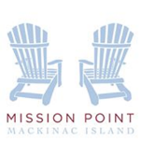
Hospitality Room - after dinner conversations | Dinner at Mission Point | May you have a safe journey home!
Please bring your auction items  To the Hospitality Room at this time | Hospitality Room  Not So Silent Auction | May you and your family be blessed with good health and happiness

A group of gracious volunteers have agreed to give us interesting presentations.
A schedule will be posted soon on the Chapter website.
Remember the schedule is fluid, presenters and topics may change as State and industry COVID-19 protocols are revised.
We are planning to move forward with this event as scheduled.

By attending the Fall Seminar, Chapter 7 members can support our essential members as they continue to share their experience and knowledge, as we learn and grow, for the benefit our right of way industry.

Our next meeting will be Thursday, November 12, 2020 at Weber’s Inn, Ann Arbor, MI.
Great speakers are lining up for this meeting too!

Please register early…thank you!

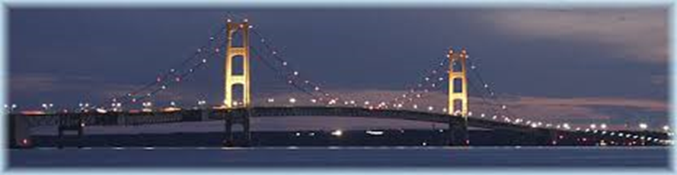

IRWA, Improving people’s quality of life through infrastructure development

